**[34] Design DFA Which Have Even Times ‘C’ Over Inputs {A,B,C}**

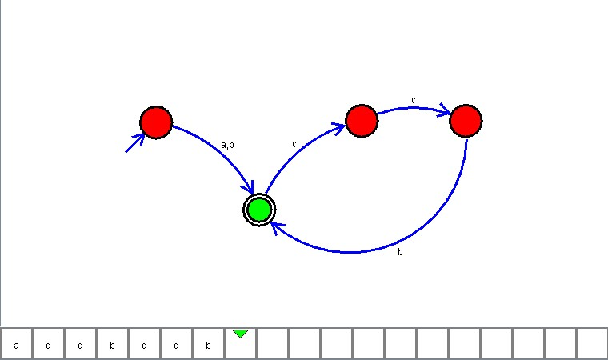

**Result**

The DFA is designed to compute the strings as input using Automaton Simulator